San Antonio Blue Bonnet Ball. 11April2026

CURRIE MOUNTAIN (R8x32) 3C (4C set) Mary Pugh New Brunswick Collection
1- 8 1s cross RH and cast 1 place, dance ½ Fig of 8 round 2s
9-16 1s turn 3s with nearer hands (1s dancing between 3s) and turn 2s with other hand
17-24 1s+3s dance RH across, 1s+2s dance LH across
25-32 2s+1s+3s dance reels of 3 on sides (1s giving RSh to 3s to start)
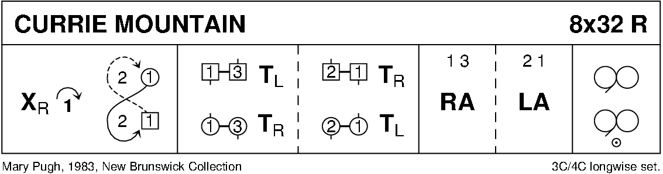

THE WILD GEESE (J8x32) 3C (4C set) RSCDS Book 24
1- 8 1s+3s set advancing and Balance-in-Line (Man above Lady), turn partners RH and 1s cast to 3rd place while 3s lead up to 1st place
9-16 3s+1s set advancing and Balance-in-Line (Man above Lady), turn partners RH and 3s cast to 3rd place while 1s lead up to 1st place
17-24 1s lead down and back to 2nd place
25-32 2s+1s dance R&L. 213
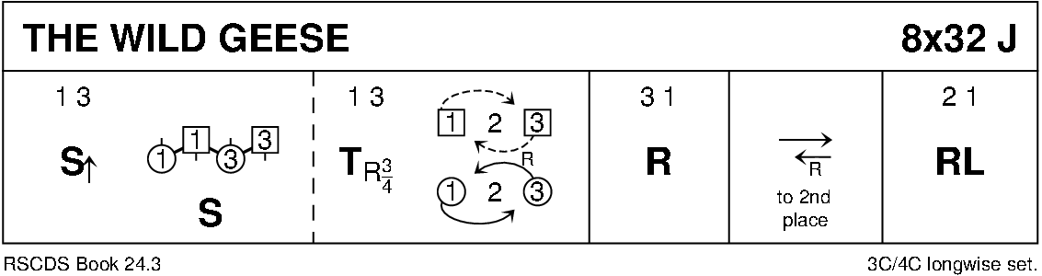

THE GENTEEL WEASEL (S8x32) 3C (4C set) Gaye Collin, 2021
1- 4 1s ½ turn RH moving down to 2nd place opposite side while 2s step up, 1s set advancing, pass LSh to finish BtoB facing own side
5- 8 1s dance out, cast to right while 2s and 3s Petronella turn; 2s+3s set while 1s dance between setting couples to 2nd place opposite side and face clockwise
9-16 2s+1s+3s dance Weasel reels:
2s+3s dance part reel of 4 up/down middle but when reaching either end they dance clockwise to top/bottom to re-enter reel while 1s dance clockwise to replace dancer leaving the reel and all end where they started, 1s facing across set
17-24 2s+3s Petronella turn to opposite sides, 2s+1s+3s join hands on the side and set. All cross RH with partner to own side and set again (retain hands)
25-32 2s+1s+3s circle 6H round to the left for 4 bars; drop hands and dance into the centre, pull back RSh and dance out and chase back to own sides. 2134
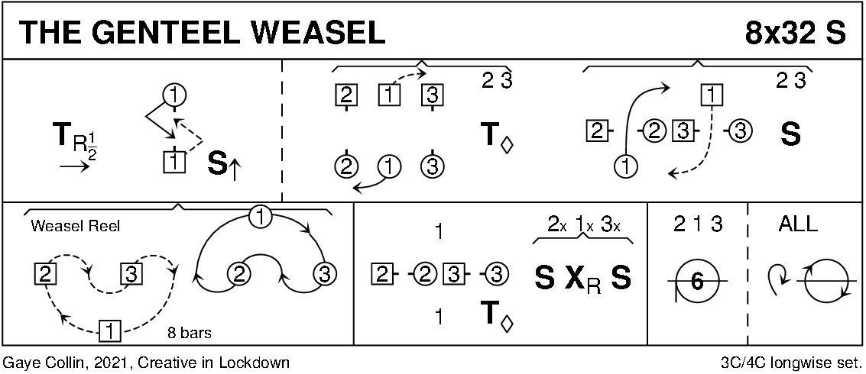

THE MUSIC MAKARS (R8x32) 3C (4C set) Roy Goldring RSCDS Book 33
1- 8 1s turn RH, cast 1 place and turn partner LH to Balance-in-Line position with 1st corners
9-16 1s Balance-in-Line with 1st corners then face 1st corners and set, 1s turn to right again and Balance-in-Line with corners then turn partner RH to face 2nd corners
17-24 1s Balance-in-Line with 2nd corners then face 2nd corners and set, 1s turn to left again and Balance-in-Line with corners then turn partner LH to end 1L facing 2s, 1M facing 3s
25-32 1s dance RH across (1L with 2s and 1M with 3s), 1s change places passing RSh and dance LH across with other couple. 213
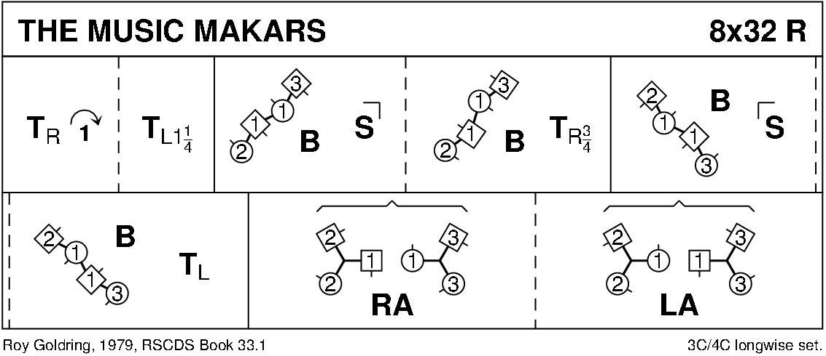

THE GATE OF DAFFODIL GARDEN (S8x32) 3C (4C set) Hiroko Higashikawa Tokai Branch 25th Anniversary
1- 8 1s followed by 2s+3s cast off to 3rd place; All set advancing and pass LSh to BtoB facing opposite sides, pull back RSh and dance round partner to own sides
9-16 3s+2s+1s dance Reverse Snowball Grand Chain for 3 couples:
1s cross RH and change places LH on side with 2s
1s change places RH with 3s while 2s cross RH
1s cross LH while 3s and 2s change places LH. 1(2)3
17-24 1s cast, dance down between 3s and cast up and turn LH to face 1st corners while bars 17-18: 2s cross up RH to 1st place own side
25-32 1s dance corners pass and turn with 1st corners (corners turn 2H), pass RSh; Repeat with 2nd corners and 1s pass RSh into 2nd place own sides
(MINICRIB. Dance crib compiled by Charles Upton, Deeside Caledonian Society, and his successors)
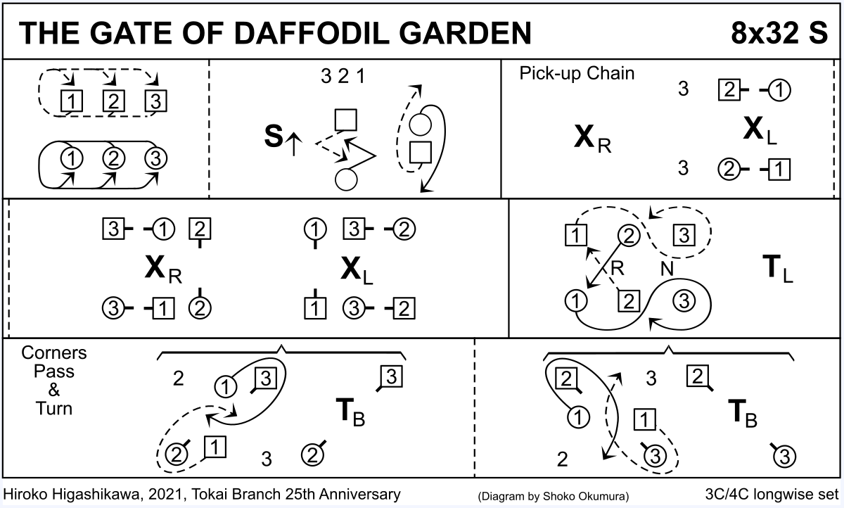

Best Set in the Hall
Helen Greenwood RSCDS Book 46
Jig 8 x 32 bars 3 Couple Repeat 4 Couple Set Longwise Set
1-2 1s set, 1L turning on the spot to finish facing out;
3-6 1s chase clockwise halfway around the set, finishing below 3s on opposite sides;
7-8 1L cast up, dance in and pull left shoulder back WHILE 1M dance up and pull right shoulder back to finish back-to-back facing first corners;
9-10 1s set to first corners;
11-12 1s pull right shoulder back and dance out to partner's first corner position WHILE first corners advance and pull right shoulder back to finish facing the corner position just vacated;
13-14 1s set to the facing corner person;
15-16 first corners (persons) pull right shoulder back and dance out to their opposite corner position WHILE 1s advance, giving right shoulder, and pull right shoulder back to finish back-to-back facing second corners;
17-22 1s repeat bars 9-16 with second corners;
23-24 second corners (persons) pull right shoulder back and dance out to their opposite corner position WHILE 1s cross, passing right shoulder, to finish 3s1s2s, all on opposite sides;
25-28 all chase clockwise halfway around the set, finishing 2s3s1s on own sides;
29-32 all turn by the right.
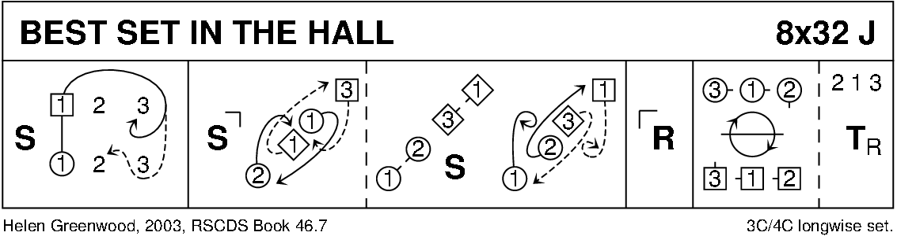

Farewell to Chernobyl 32R3 3 cpl set Roby 2018 Try this music https://www.youtube.com/watch?v=GS8ktEPq47I

1-6 All set, dance forward and back
7-8 1s and 2s dance RH across half way while 3s cross by the right
9-16 All set, dance forward and back
All half turn by the right hand into promenade hold facing up
17-24 All dance a three couple allemand
26-32 1s cross by the RH, turn 1st corner by the left hand,
second corner by the right hand, partner by the left hand to
own side in progressed position
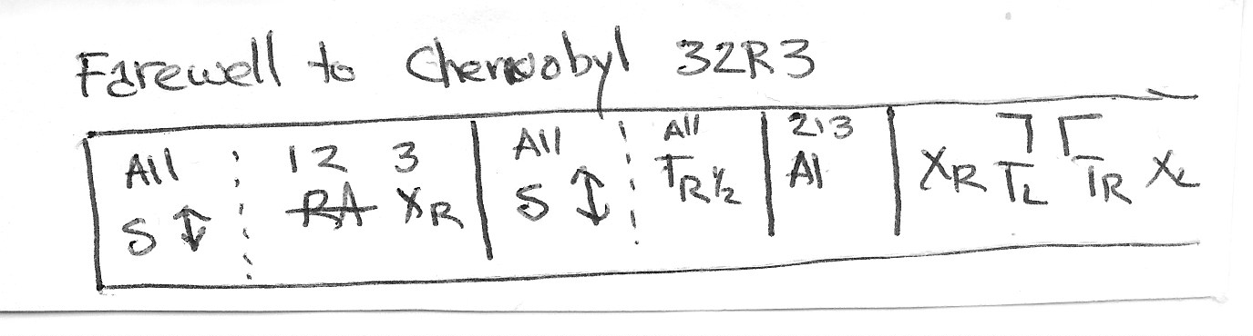

UP AND DOWN BEN NEVIS (S3x32) 3C set M Ross Diamond Jubilee Collection
1- 8 3s set and cast up behind 2s, dance up between 1s (2s step down) and cast to 2nd place own sides. 132
9-16 3s dance ½ reels of 3 across (3M at top, 3L at bottom, RSh to 2nd corner) and dance ½ reels of 3 across with other couple (RSh to 4th corner)
17-24 1s+3s set and link, 1s+2s set and link. 321
25-32 2s followed by 3s dance Fig of 8 round 1s. 231
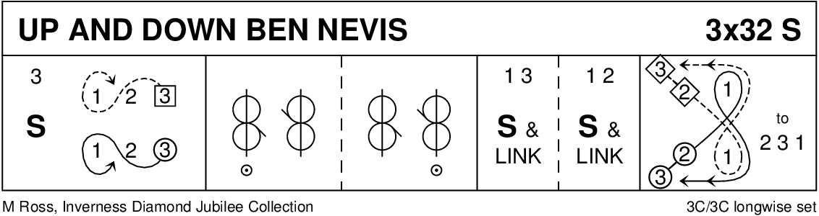

ELINOR OF BRIAR LEA (J8x32) 2C (4C set) John Roby Houston and District 30th Anniversary
1- 8 1s+2s dance ½ R&L; 1s+2s turn partner 1¼ RH to face partner in line up/down centre, Men facing up, Ladies facing down
9-16 All set, dance ½ reel of 4, middle couple (2M+1L) turn 1¼ LH while partners chase clockwise ¼ round to face partner again in line across
17-24 All set, dance ½ reel of 4, middle couple (2M+1L) turn 1¼ LH while partners chase clockwise ¼ round to face partner again in line up/down centre
25-32 1s+2s dance ½ reel of 4; all turn partner 1¼ RH to own side. 2 1
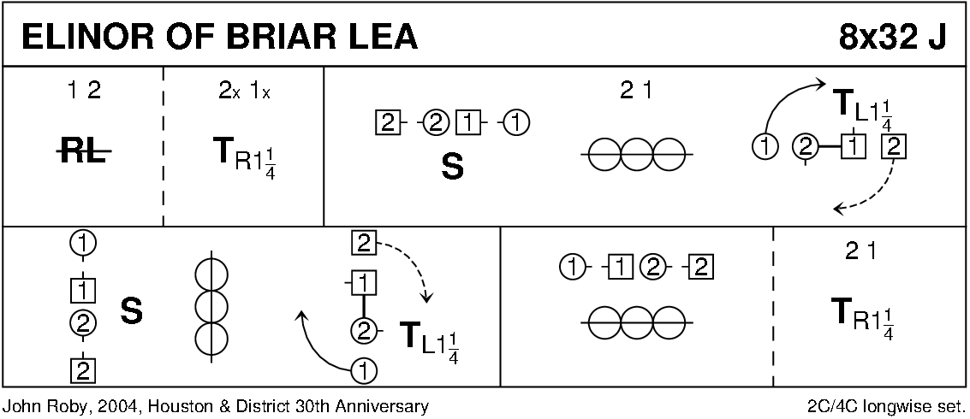

Intermission

Duke of Perth
Anon RSCDS Book 1
Reel 8 x 32 bars 3 Couple Repeat 4 Couple Set Longwise Set
1-4 1s turn by the right and cast;
5-8 1s turn by the left, finishing facing first corners;
9-16 1s turn corner, partner, corner, partner;
17-20 1s set to first corners and turn both hands;
21-24 1s set to second corners and turn both hands;
25-30 2s1s3s reels of 3 on sides (left shoulder to first corners to start);
31-32 1s cross to own sides, finishing 2s1s3s.
(MAXICRIB. Scottish country dancing instructions compiled by Reuben Freemantle)

Keith Rose's Crib Diagram
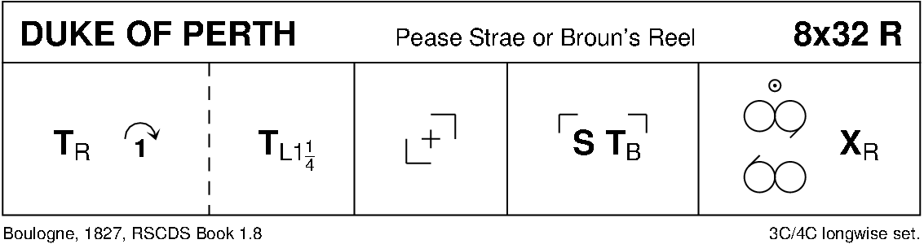
Balmoral Strathspey
John A Charles RSCDS Book 22
Strathspey 4 x 32 bars 4 Couple Repeat 4 Couple Set Longwise Set
1-8 1s2s 3s4s rights and lefts;
9-10 1s2s 3s4s set facing partners;
11-12 1s2s 3s4s right hands across halfway;
13-14 2s1s4s3s set facing partners;
15-16 2s 1s 4s 3s cross by the right to own sides;
17-24 2s1s4s3s reels of four on own sides, 2s finishing in 1st place, 1s 4s 3s on the centre line, facing up in allemande hold;
25-32 2s stand WHILE 1s4s3s allemande, finishing 2s3s4s1s.

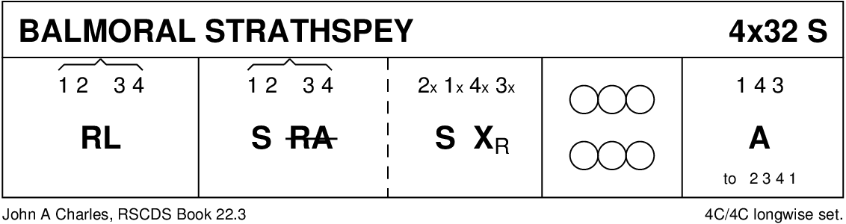
MRS STEWART'S JIG (J8x32) 3C (4C set) Frans Ligtmans RSCDS Book 35
1- 8 1s set, 1L followed by partner casts 2 places, 1L crosses (below 3s) and casts up on Men's side to 2nd place facing down while 1M dances round 3L and up the middle to 2nd place Ladies' side facing down
9-16 2s+1s+3s dance Grand Chain, end with 2M and 1M facing out
17-24 2s+1s dance Ladies' Chain
25-32 2s+1s+3s advance and retire; 1s turn 1½ RH to own sides. 213
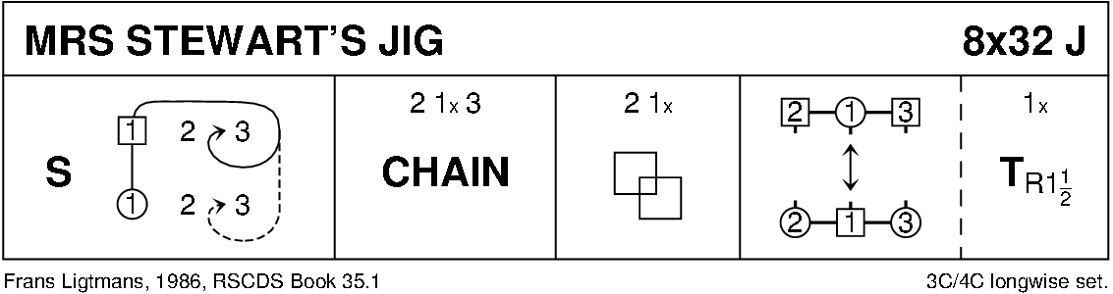
J. B. MILNE (R8x32) 3C (4C set) Hugh Foss Angus Fitchett Album
1- 8 1M+2L set advancing and turn RH, 1L+2M set advancing and turn RH
9-16 1s set advancing to each other and turn 2H, cast to 2nd place and Petronella turn to Lady between 2s and Man between 3s
17-24 1s set and ¾ turn RH while 2s+3s change places RH on sides and set, 1s repeat but 2s and 3s cross RH and set
25-32 1s set and change places RH while 2s+3s change places RH on sides and set, 1s cast round corner to 2nd place own sides as 2s+3s cross RH and all set
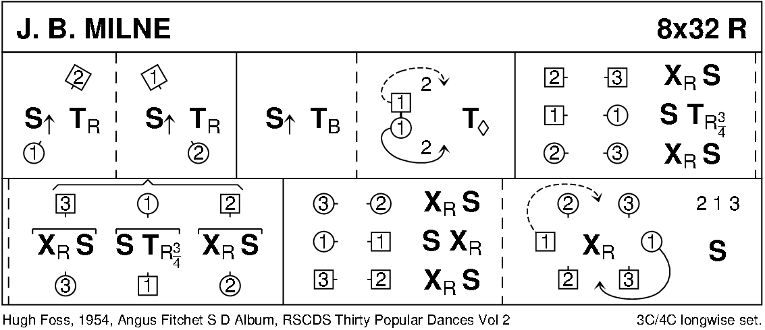

FOLLOW ME HOME (J8x32) 3C (4C set) Ellie Briscoe RSCDS Book 38
1- 8 1s set and cross RH, cast 1 place and turn LH (ending in a diagonal line LH to partner and RH with 1st corner)
9-16 1s Balance-in-Line with 1st corners, ½ turn corners and 1s followed by corners chase clockwise to 3rd corner (position), 1s dance in, join RH with partner and LH with 2nd corners
17-24 1s Balance-in-Line with 2nd corners, ½ turn corners and 1s followed by corners chase anticlockwise to 4th corner (position), 1s crossing LSh to 2nd place opposite sides facing out
25-32 3s+1s+2s dance ½ reels of 3 on the sides 1s giving LSh to 2nd corner (position); 2s+1s+3s set and cross RH. 213
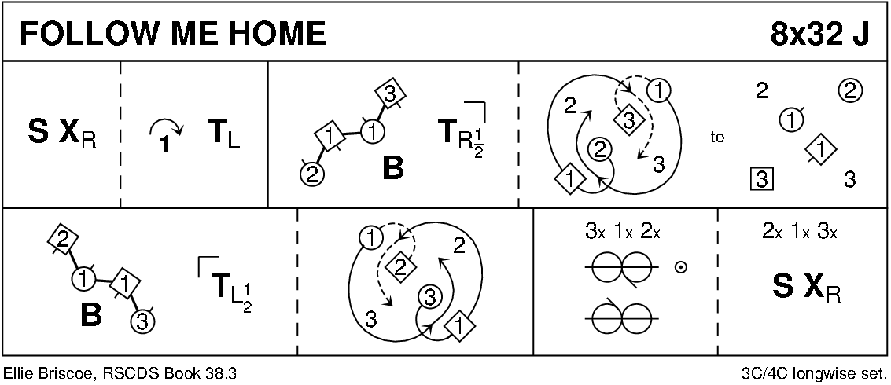

CITY OF BELFAST (S3x32) 3C set Lucy Mulholland Belfast Diamond Jubilee Book and RSCDS Book 48
1- 8 1s dance ½ Fig of 8 round 2s, 1L+2M turn RH 1¼ times while 1M+2L turn LH 1¼ times and 1s end BtoB facing opposite sides
9-16 1s+2s dance reel of 4 across in 2nd place. 2s end in 1st places while 1s pass LSh to face 1st corners
17-24 1s set to 1st corner and 2nd corner ending (turning to right) between corners, all set and 1s cross RH
25-32 1s+3s dance Espagnole:
25-26 1s+3s cross (Ladies lead across RH passing between Men) with Ladies changing places RH
27-28 1s+3s cross back (Men lead across RH between Ladies) with Men changing places RH
29-32 3s turn RH as 1s turn LH. 231
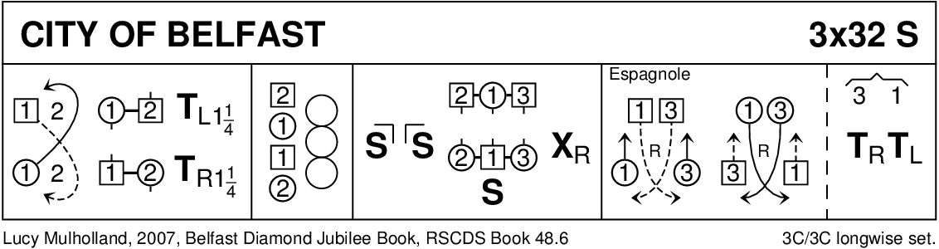

RED GHILLIES (R4x40) 4C set Ann Skipper and Neil McLeod If The Ghillie Fits
1- 8 1s cross down, cast down behind 3s, cross down and cast up around 4s to 3rd place
9-16 1s cross up, cast up behind 2s to 1st place and turn RH 1½ times
17-24 1s+2s dance ½ R&L, 1s+3s dance ½ R&L
25-32 1s+4s dance ½ R&L and all turn RH
33-40 All set and dance a modified La Baratte:
Men ½ turn partners RH and retain hand but at arm's length from each other, Men retrace steps with partner turning right under his arm briefly into Allemande hold (Men behind partner facing Men's original place) and releasing partner's RH she turns under Man's left arm and all change places LH to own sides
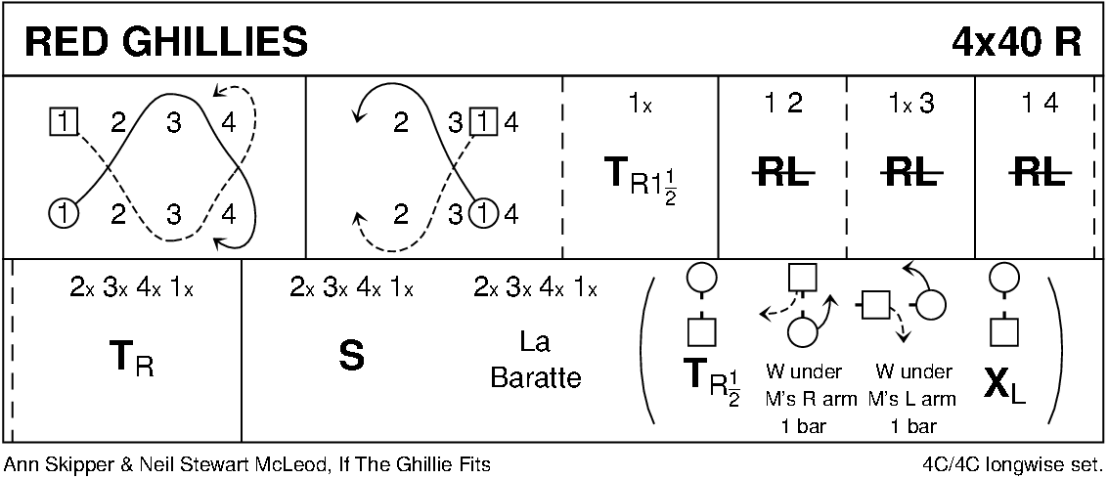

MACDONALD OF THE ISLES (S3x32) 3C set Derek Haynes Carnforth Collection 2
1- 8 2s dance full diagonal Reels of 4 with 1st corners, passing by the LSh to face 2nd corners
9-16 2s dance full diagonal Reel of 4 with 2nd corners to end in original places
17-24 All dance Snowball Grand Chain for 3 couples:
1s cross RH and change places LH on side with 2s
1s change places RH with 3s while 2s cross over RH
1s cross LH while 2s and 3s change places LH. 3(2)1
25-32 3s+2s dance ½ R&L, 3s dance ½ Fig of 8 round end couples (3M up and 3L down) to end in 2nd places. 231
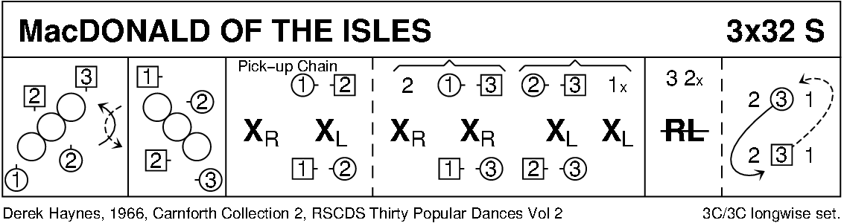

GOOD HEARTED GLASGOW (J8x32) 3C (4C set) Peter Knapman Guide To SCD (ex-Collins)
1- 8 1s turn RH and cast to 2nd place, turn partner LH 1¼ times
9-16 1s dance RH across (Lady with 2s at top and Man with 3s); 1s pass RSh and dance LH across with other couple
17-24 1s lead down the middle and back to 2nd place own side
25-32 2s+1s+3s circle 6H round and back. 213
